Advices for better manipulation of Abaqus
Mouse manipulation
1/ Click on the “Option” in Tools section
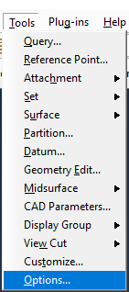
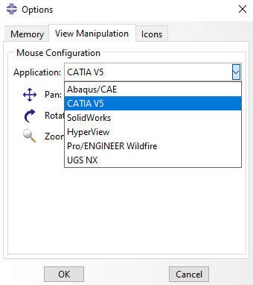
2/ Then Select CATIA V5 in View Manipulation
Color background
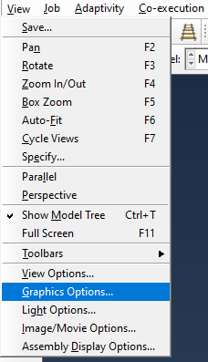
1/ Select “Graphics Options” in View section

2/ Click on Solid
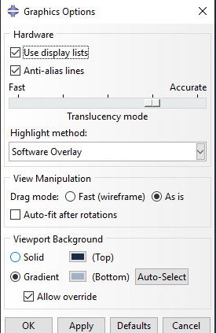

3/ Double-Click on colored rectangle and select white color, then click OK – Apply/OK
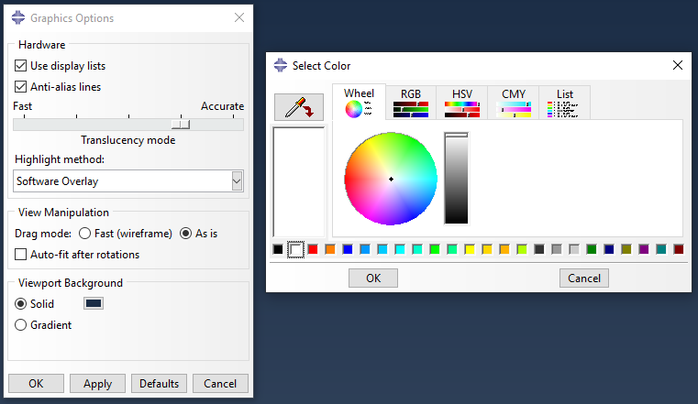
1
2
Display option

1/ Select the Assembly Module (or visualization for results)

2/ Select the Display group button

3/ Select Part/Model instance in item and select part to remove or to add
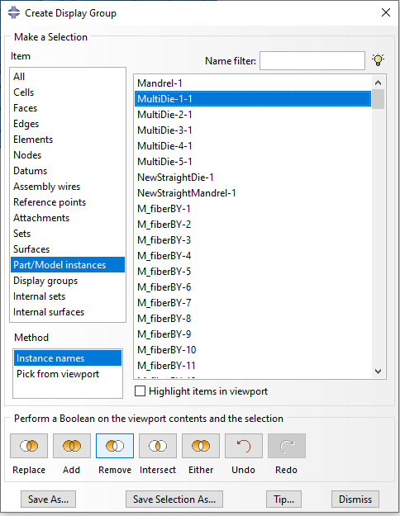

Color option

1/ Select the color code dialog

2/ Select Part instances
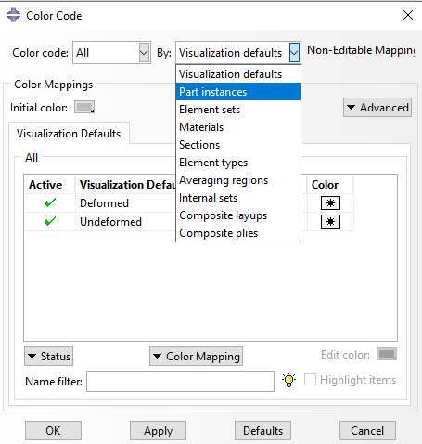

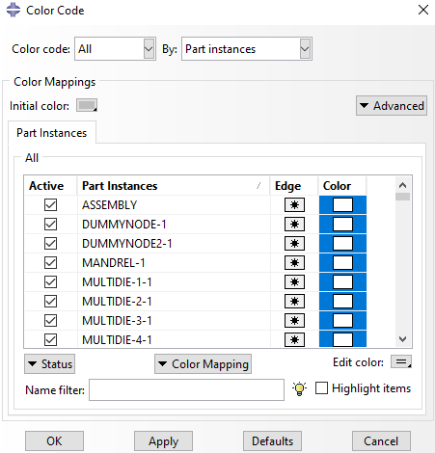
3/ Select all parts by shift+click to have the same color and double-click on the edit color box then choice the color

Truss display
1/ Selct the ODB display options
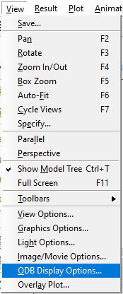
2/ Click on the Render beam profiles option then click on apply button
